H.T No
Regulations:
A15


Sreenidhi Institute of Science and Technology
(An Autonomous Institution)
Code No: 5B518 Date: 20-Dec-2018 (FN)

B.Tech III-Year I-Semester End External Examination, Nov/Dec - 2018 (Regular)
Design of Machine Members-I (ME)

Time: 3 Hours Max.Marks:75

Note: a) No additional answer sheets will be provided.
b) All sub-parts of a question must be answered at one place only, otherwise it will not be valued.
c) Missing data can be assumed suitably.

Part - A Max.Marks:25

Answer all QUESTIONS.

1. | Represent the basic design procedure as a flow chart. | [3M]
2. | What do you understand by Endurance limit.. how is it calculated? | [3M]
3. | What is the function of keys? Give examples. | [3M]
4. | Give an account of the applications of springs. | [3M]
5. | Identify the applications of screws and threaded joints. | [3M]
6. | What are the various types of welded joints used in Pressure vessels? | [2M]
7. | Demonstrate BIS system of designation of steels. | [2M]
8. | List various couplings used in Industry and give their applications. | [2M]
9. | What is stress concentration? How can it be reduced? | [2M]
10. | What do you understand by stress amplitude ratio? Why it is required? | [2M]
Part – B Max.Marks:50
ANSWER ANY FIVE QUESTIONS. EACH QUESTION CARRIES 10 MARKS.

11. | a) | Discuss various failure modes of failures of Mechanical components. | [5M]
 | b) | What is factor of safety? What are the factors that affect the factor of safety? | [5M]
12. |  | A component machined from a plate made of steel 45C8(S_{ut}=630 N/mm²). It is subjected to a completely reversed axial force of 50KN, the expected reliability is 90% and the F.S. is 2, the size factor is 0.85.Determine the plate thickness for infinite life , if the notch sensitivity factor is 0.8.( see fig.1).  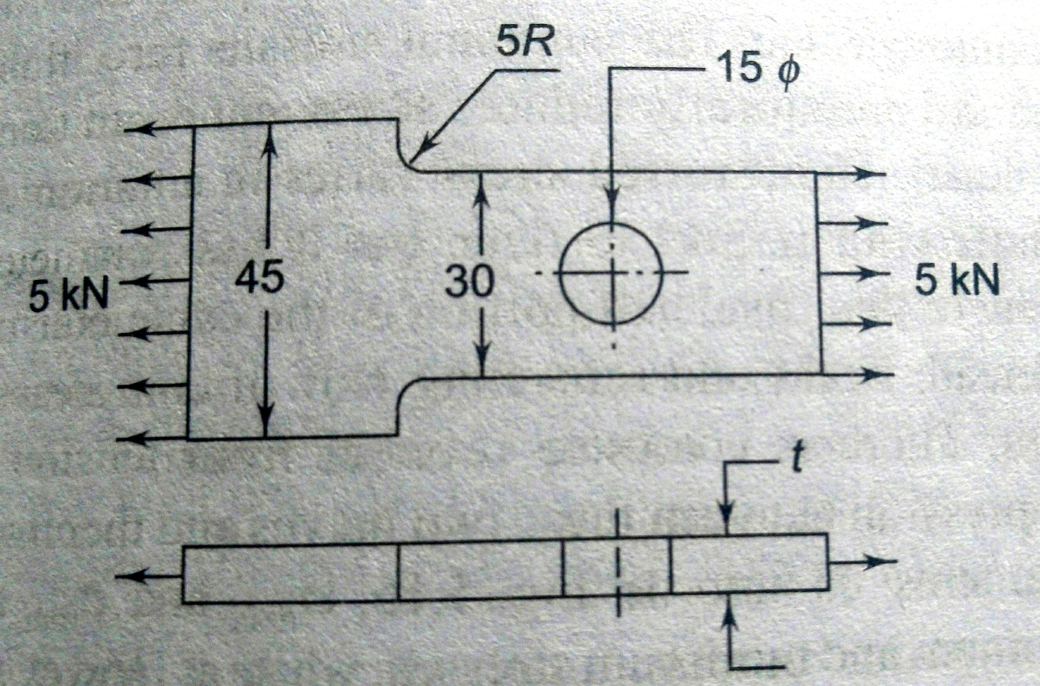  Fig.1. ( all dimensions in mm) | [10M]
13. |  | It is required to design a square key for fixing a pulley on the shaft, which is 50mm in diameter the pulley transmits of 10 KW power at 200 rpm to the shaft. The key is made of steel 45C8 (S_{y}=S_{e}=380N/mm²) and the factor of safety is 3. Determine the dimensions of the key.(Assume S_{sy} =0.577S_{yt}). | [10M]
14. |  | It is required to design a helical compression springs subjected to max. force of7.5KN. The mean coil diameter should be150mm from space consideration. The spring rate is 75N/mm. S_{u} = 1250N/mm².The permissible shear stress of the material is 30% of the ultimate strength. G = 81370 N/mm^{2.} Calculate the wire diameter and the no. of coils. | [10M]
15. |  | Design a double riveted butt joint with two cover plates for the longitudinal seam of a boiler shell 1.5 m in diameter subjected to a steam pressure of 0.95 N/mm². Assume joint efficiency as 75%, allowable tensile stress in the plate 90Mpa, compressive stress 140 Mpa, and shear stress in the rivets 56Mpa. | [10M]
16. |  | A rectangular cross section of bar is welded to a support by means of fillet welds ( refer fig.2).Determine the size of the weld. If the permissible shear strength of the weld is limited to 75MPa.  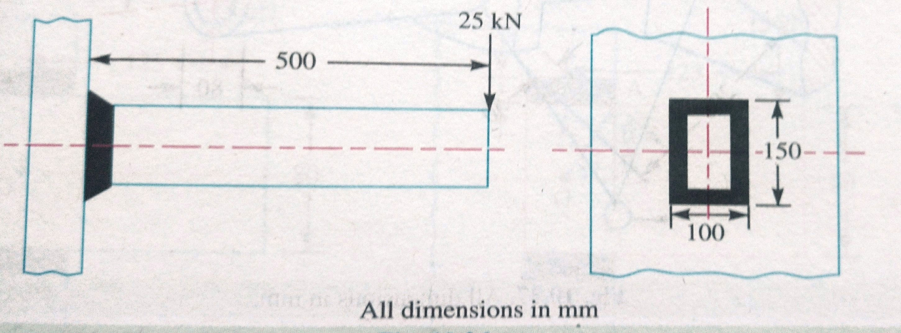  Fig.2 | [10M]
17. | a) | Write about the application of principle stresses in design. | [3M]
 | b) | What are the factors considered while designing machine parts to avoid fatigue failure. | [3M]
 | c) | Discuss the effect of keyways in on the strength of the shaft. | [4M]
18. | a) | Discuss the effect of Surge in springs. | [3M]
 | b) | Discuss the concept of Stresses due to combined loading in screwed joints. | [3M]
 | c) | Give a brief account on the designing of circular fillet weld subjected to Torsion. | [4M]

-- 00 -- 00 –

